Recursive SQL - Demo
Example 1: Displaying top to bottom hierarchy
with directreports(Manager_No,Employee_No,Employee_Name,EmployeeLevel) as
(
select mgr,empno,ename,0 as EmployeeLevel
from emp
where mgr is null
Union All
Select e.mgr,e.empno, e.ename,EmployeeLevel + 1
from emp e INNER JOIN directreports d
on e.mgr = d.Employee_No)
SELECT Manager_No,Employee_No,Employee_Name,EmployeeLevel
FROM DirectReports;

Note For recursion CTEs the column aliases after the CTE name are mandatory.
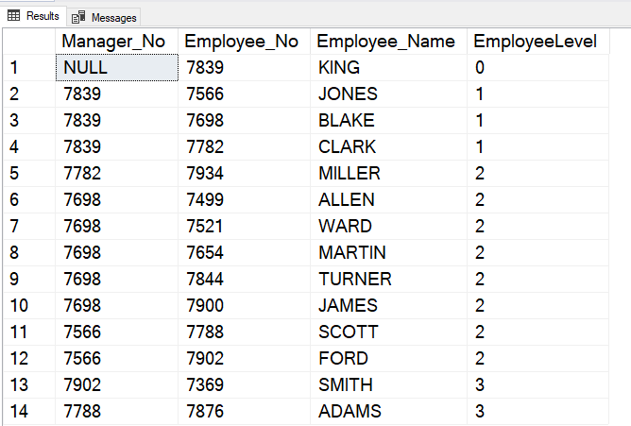

For the first time following matching records are found:
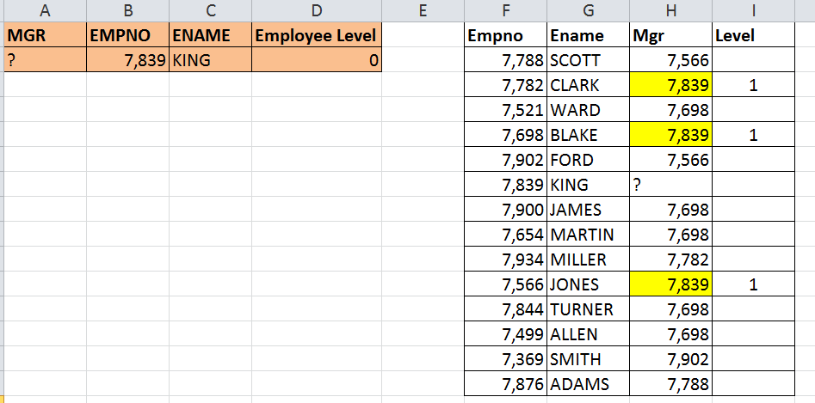

For the second time following matching records are found:
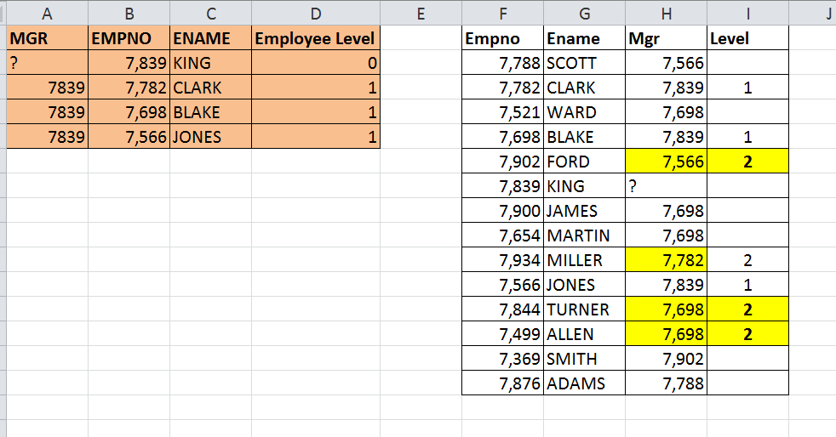

Example 2: Displaying bottom to top hierarchy
with
directreports(Manager_No,Employee_No,Employee_Name,EmployeeLevel) as
(
select mgr,empno,ename,0 as EmployeeLevel
from emp
where mgr is null
Union All
Select e.mgr,e.empno, e.ename,EmployeeLevel + 1
from emp e INNER JOIN directreports d
on e.mgr = d.Employee_No)
SELECT Manager_No,Employee_No,Employee_Name,EmployeeLevel
FROM DirectReports
Order by 4 desc

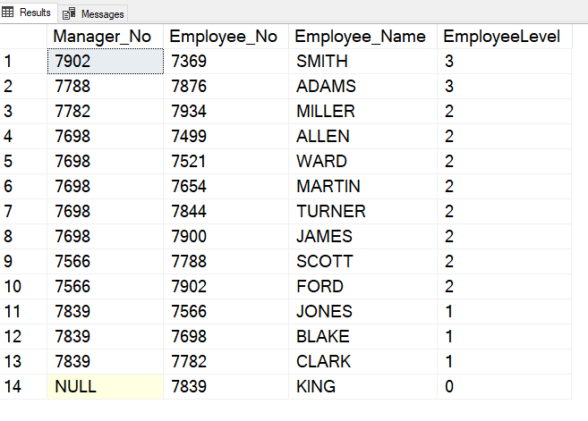

Example 3: Employees reporting to King
with
directreports(Manager_No,Employee_No,Employee_Name,EmployeeLevel) as
(
select mgr,empno,ename,0 as EmployeeLevel
from emp
where mgr is null
Union All
Select e.mgr,e.empno, e.ename,EmployeeLevel + 1
from emp e INNER JOIN directreports d
on e.mgr = d.Employee_No)
SELECT Manager_No,Employee_No,Employee_Name,EmployeeLevel
FROM DirectReports
where Manager_no = (select empno
from emp
where ename = 'KING');

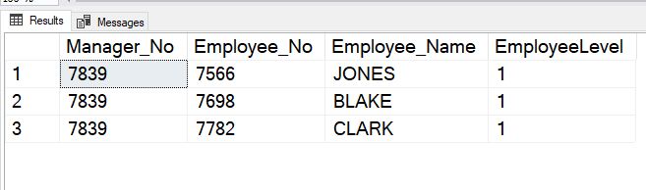

Example 4: Maximum recursion 100 getting exhausted, kind of infinite loop…..
with
directreports(Manager_No,Employee_No,Employee_Name) as
(
select mgr,empno,ename as EmployeeLevel
from emp
where mgr is not null
Union All
Select d.Employee_no,d.Manager_no,d.Employee_Name
from directreports d INNER JOIN emp e
on d.Manager_no =e.empno)
SELECT Manager_No,Employee_No,Employee_Name
FROM DirectReports;

ORA-32044: cycle detected while executing recursive WITH query
Note: If the on clause returns false for the first pass of the data then maximum recursion 100 gets exhausted before statement completion.

